1. Overview
Q&A (0)
As you learned in the previous tutorial, there are two types of animation that you’ll commonly be working with in Unity: imported, and in-editor generated. You’ll begin your animation journey with in-editor animations. Practically anything, from GameObjects and their individual components, can be animated in Unity. You can animate an object’s material to change color over time, toggle a light off and on, trigger a script, and more.
In this tutorial, you’ll learn the basic principles of animation and the tools available to you in Unity by animating a ball. This is a classic exercise for new animators, both digital and traditional alike.
As you prepare to create your first 3D animation, let’s hear from our creators about what animation brings to real-time 3D experiences:
Play Video
Mark step incomplete
2. Create an Animation Clip
Q&A (0)
In Unity, individual animations are stored in an asset called an Animation Clip. They are associated with the object selected at the time of the clip’s creation, and store all data that goes into creating a specific animation. Animation clips can be any length of time, and a single GameObject can have multiple Animation Clips associated with it.
1. In the Hierarchy, select the Ball GameObject.
In the Animation Editor, notice that a Create button has appeared in the main work area. This button will always appear for any selected object that doesn’t yet have any animation associated with it. If you select an object that has already been animated, the first animation created will be shown in the Animation Editor instead.
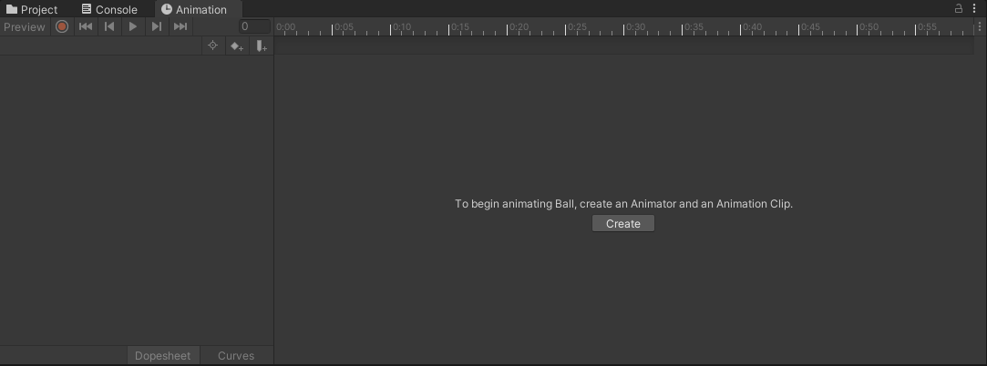
2. Click the Create button and Unity will prompt you to select a save location for your animation.
3. Name the animation Ball_Pulse, then Save it in the Animations folder
When you save the new Animation Clip, the appearance of the Animation window changes. The left side of the window now features an Add Property button where you can add and view the properties you wish to animate. Directly above this button is the name of your current Animation Clip in a dropdown menu. If you choose to have multiple animations on the same GameObject, you can select the one you wish to view from this menu.
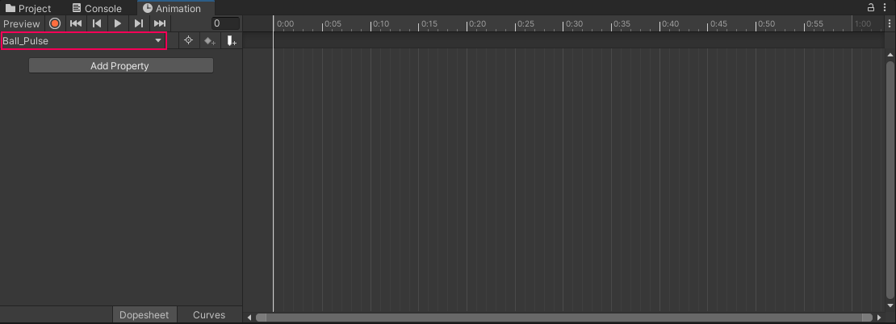
The body of the animation window will now display a timeline where you can create your animation.
Mark step incomplete
3. Set the animation keyframes
Q&A (0)
Just as an animation is contained within an Animation Clip, the specific poses within an animation are defined by its keyframes. In traditional hand-drawn animation, keyframes are the poses that lead animators draw, and are important (or key) drawings that define the animation sequence. Once the lead animators finish these key poses, other animators draw the frames between them to complete the animation. These frames are referred to as in-between frames, also known as tweens.
In digital animation, tweening is generally handled by whatever tool the animator is working with, meaning they only need to worry about setting up keyframes. Digital keyframes record all the data related to the GameObject being animated at a defined time stamp. Let’s see this in action by creating a simple pulse animation with the ball.
1. Make sure the ball is still selected in the Hierarchy
2. Click the Add Property button on the left side of the Animation window, and then select the dropdown next to Transform to reveal the Scale Property. Select the + button to add it to the animation.
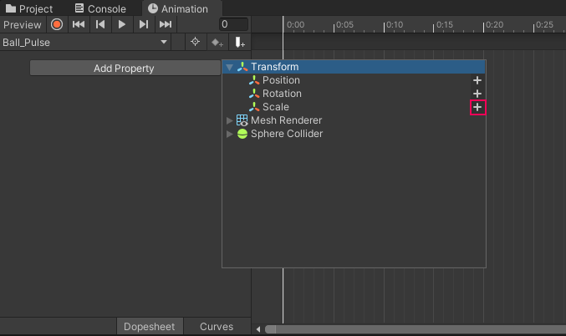
Two diamond icons will appear at the start of the timeline. These icons represent keyframes.
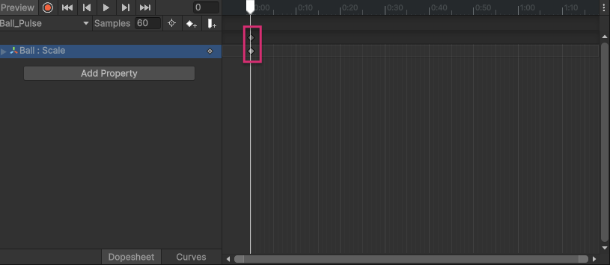
When a new property is added to an animation, the Animation editor records the relevant data (in this case, the ball’s current scale) about the selected object and generates initial keyframes for it.
You’ve set the initial keyframes, but you haven’t really animated anything yet. To do so, you’ll need to modify the ball mesh in the scene, and then set another keyframe to record the change. There are multiple ways to accomplish this, but the easiest is making use of the Record button in the Animation editor, which will automatically detect when you make any changes to your model and generate keyframes to record the changes.
3. Select the circular Record button at the top left of the Animation window to activate recording mode.
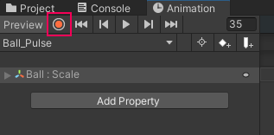
Once the Record button is pressed, both it and the timeline will be highlighted in red. So long as the Record button is active, Unity will automatically add keyframes for any property that is changed in the Inspector.
4. Click on the timeline at the 25 mark.
The white vertical line will move to that position. This line is called the Playhead.
The Playhead indicates which frame is currently active and where new keyframes will be created.
5. With the Playhead at frame 25, switch to the Scale tool by pressing R on your keyboard. Increase the size of the Ball in the Scene view.
Because Record mode is active, Unity automatically creates a new keyframe at frame 25.
6. Now move the Playhead to the 60 mark on the timeline. Select the first keyframe at frame 0 and duplicate it by pressing Command + C followed by Command + V (Windows: Control + C then Control + V). This ensures the Ball returns to its original scale at frame 60.
7. Press the Play button in the Animation window (next to the Record button) to preview the animation.
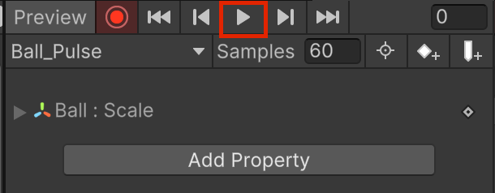
Even though you only set three keyframes, the Ball will smoothly pulse from its starting scale to the size you changed it to, and then back.
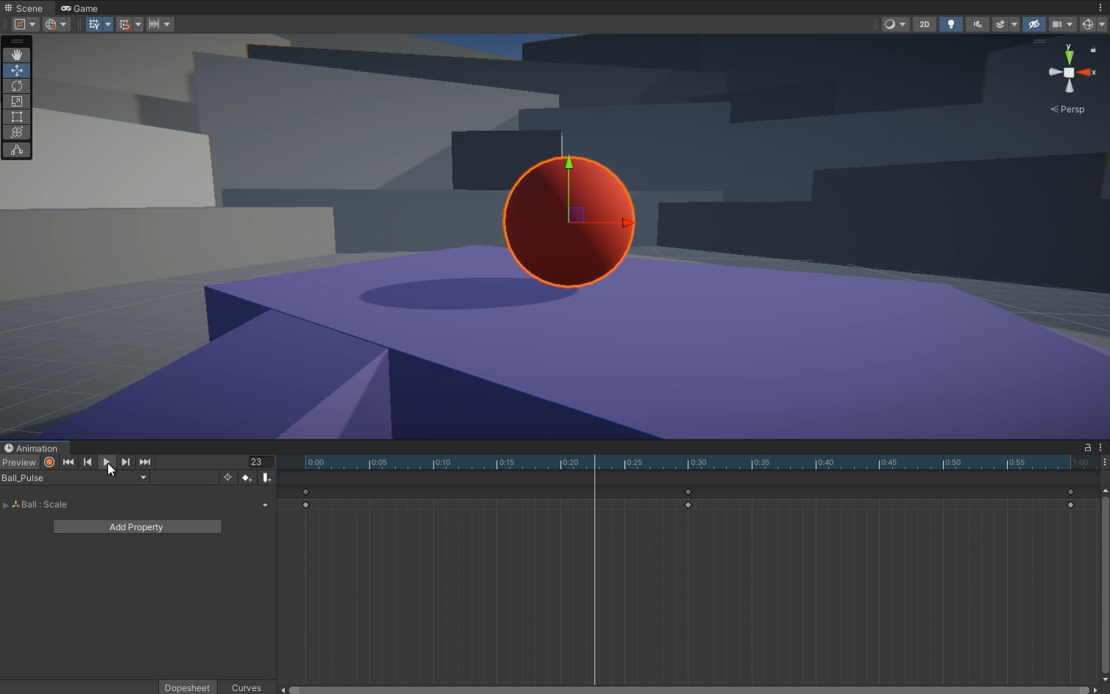
Play Video
You can edit keyframes at any time. Move the Playhead to the frame you want to adjust, select the keyframe, and modify the value. As long as Record mode is active, your changes will overwrite the previous values.
To delete a keyframe, select it and press the Delete key.
When you first added the Scale property, you may have noticed two diamond icons at each keyframe position:
- The lower diamond represents the keyframe for that specific property.
- The upper diamond selects all keyframes at that time marker.
This is especially useful when multiple properties are animated at the same frame, as it allows you to move them together.
8. Select the top keyframe at the 25 mark and drag it to frame 30 to adjust the timing.
9. Click the Record button again to deactivate recording mode.
Mark step incomplete
4. Create a second clip
Q&A (0)
A single object can have an infinite number of Animation Clips. Let’s continue working with the ball to create a second animation, this time a looping bounce. Creating a bouncing ball animation is a classic exercise for both traditional and digital animators; they’re simple, but allow new animators to experiment with several animation principles. Let’s take a look at what you’re creating next:
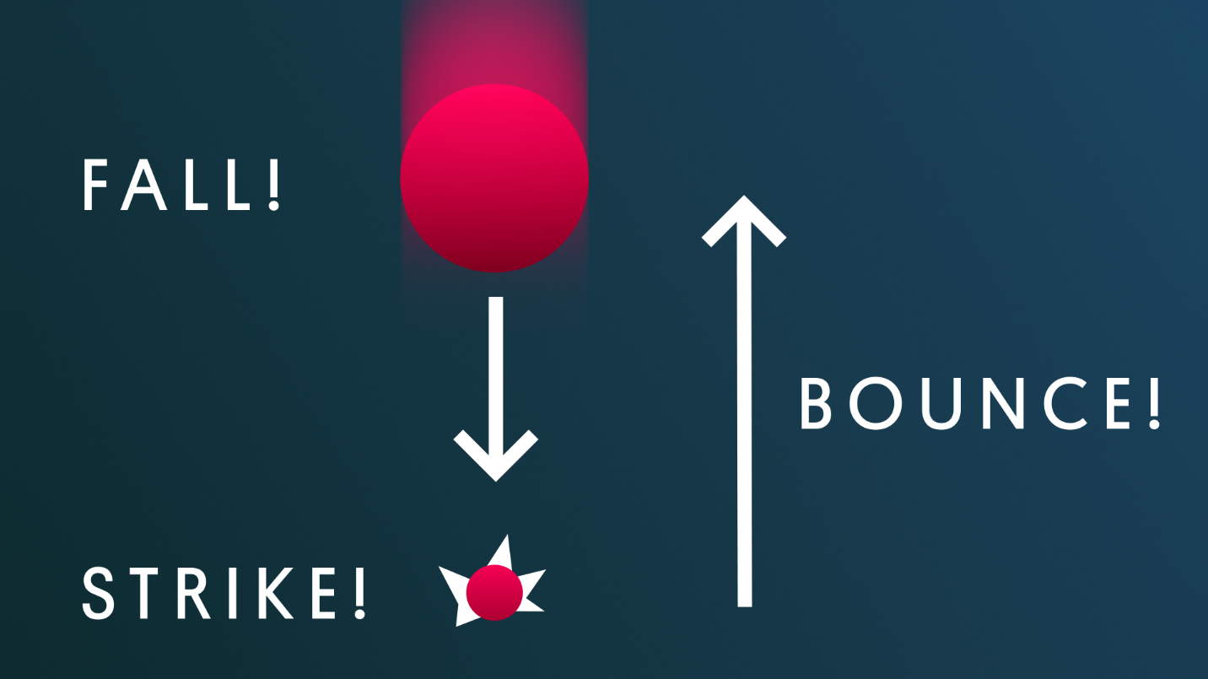
There are three major points to create keyframes for: the ball falling, the ball striking the ground, and the ball bouncing back up. Let’s get to it!
1. With the ball selected in the Hierarchy, use the top left menu under playback controls that lists Ball_Pulse as the current animation, and select Create New Clip.
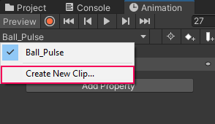
2. When prompted, save the new Animation Clip as Ball_Bounce in the Animation folder.
The animation window will clear of keyframes, but don’t worry–the pulse animation data is stored safely in its clip.
Since this animation is more reliant on timing than the previous clip, it may be helpful to have the timeline display seconds rather than frames.
3. Select the three vertical ellipsis in the upper right hand corner of the Animation window on the same level as the timeline and select Seconds.
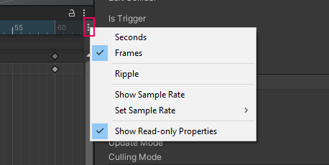
By default, Unity animations have a frame rate (FPS) of 60. This means that for every second of animation, 60 frames are rendered on the screen. This produces very smooth animation; however, the more common frame rate for animation is 24 FPS. This is also the frame rate for most movies. The frame rate that you choose to animate in ultimately comes down to personal preference, but make sure you use the same rate consistently across all animations in your project. This is especially important to keep in mind if you intend to use imported animations from a DCC or the Unity Asset Store, which are often at 24 FPS.
4. Click on the same three vertical ellipsis button from the previous step, and go to Set Sample Rate > 24.
Note: It’s important to understand the way numbers are displayed in the timeline for animations with a sample rate lower than 60 frames per second. The first number before the colon is the second of animation, while the number after the colon is the current frame. 1:22 for example, means the 22nd frame of animation within the first second.
Mark step incomplete
5. Create the bounce animation
Q&A (1)
1. In the scene, select the Ball and drag it above the ground plane by around three units, or whatever height you prefer.
2. Click the Record button in the Animation editor so you can immediately begin editing your keyframes.3. Select the Add Property button in the Animation editor and then click the down arrow to the left of the Transform option to reveal the different Transform Properties. Select the + button on the right side of Position.
4. Place your cursor over the timeline and scroll with your mouse wheel, or drag the bottom scrollbar until you can see frame 1:10.
5. Move the Playhead to frame 1:10. Then select the first keyframe at frame 0 and duplicate it by pressing Command + C followed by Command + V (Windows: Control + C then Control + V).
This ensures the Ball returns to its starting position at the end of the animation.
6. On the numbered section of the timeline, click approximately halfway between the start and end frames. In the Scene view, move the Ball so that it rests on the ground plane, being careful to modify only the Y position.
Because Record mode is active, Unity automatically creates a new keyframe at that point.
7. Preview the animation by pressing the Play button in the Animation window.
Mark step incomplete
6. Next steps
Q&A (0)
Play Video
The basic bounce is complete! If you look closely though, while your ball is animating smoothly, it doesn’t exactly look how you might expect a bouncing ball to look. It seems to be softly floating up and down rather than falling and bouncing. In the next tutorial, you’ll refine the animation to make it appear more realistic.

